**Utilizing LinkedIn – Find out who is hiring “Data Engineers”**

Run search for newly hired Data Engineers in the Chicago-Land Area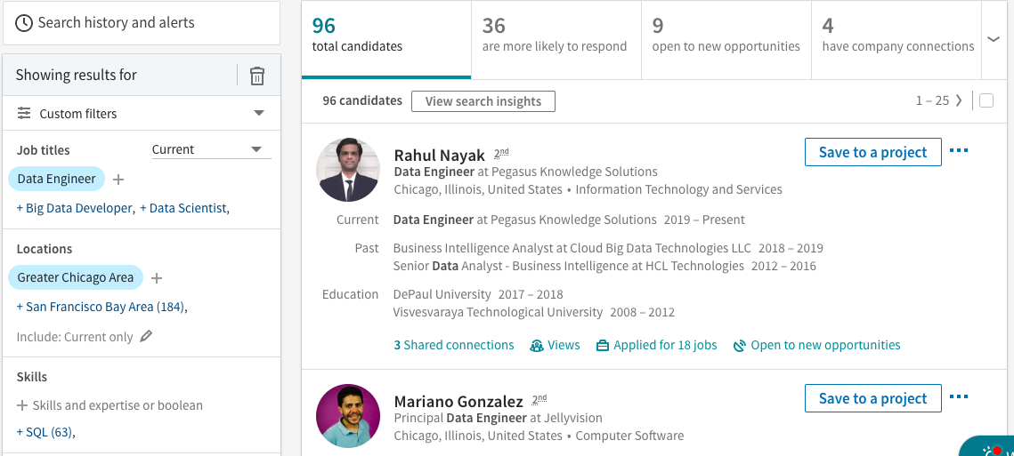

* + Job Title - “Data Engineer”
    - Select “Current”
  + Location: Greater Chicago Area
  + Years at current company “Less than 1”
  + Company size “201-500” & ”501-1000” (Can be creative here)

Select “View Search Insights” tab just below the total candidates

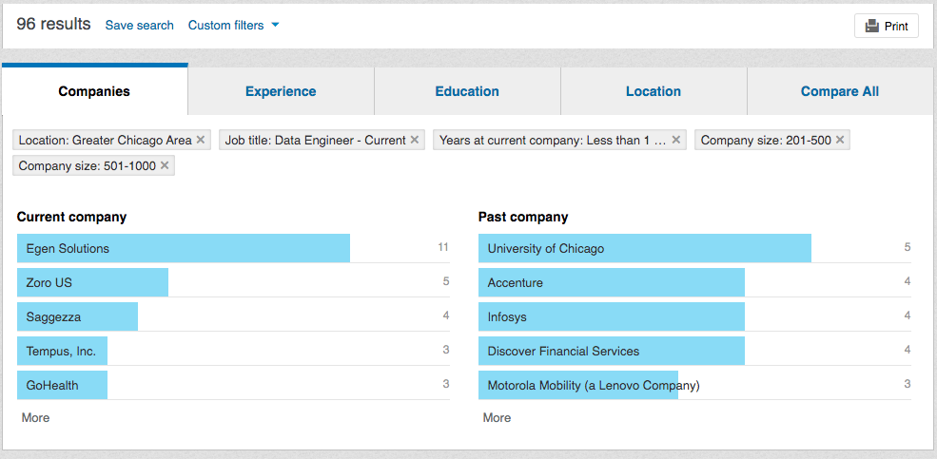

* + This shows which companies have hired the most Data Engineers this year
  + This will also show which companies they were pulled from

Save that search and be alerted anytime a new Data Engineer is hired

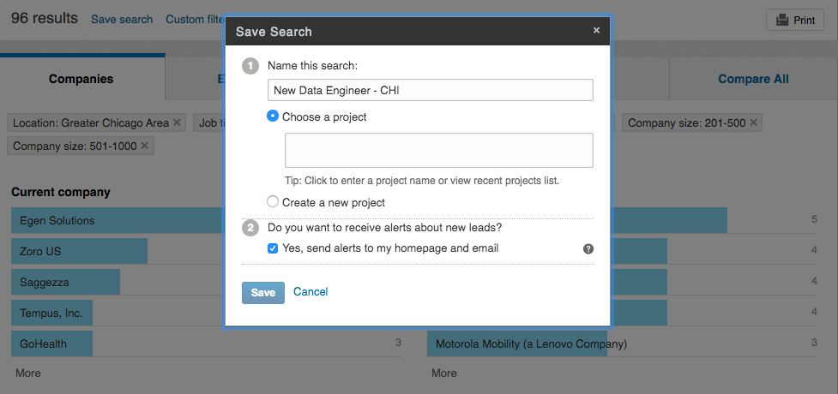

**Utilizing LinkedIn: Target Accounts - See when people are joining your Target Accounts**

Search Job title of roles we would hire - Data Engineer

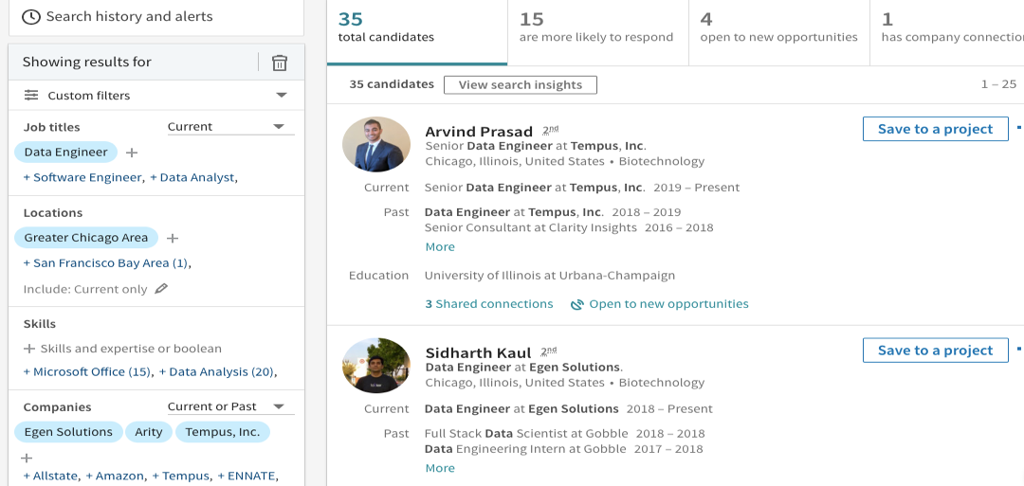

* + Job Title - “Data Engineer”
    - Select “Current”
  + Location: Greater Chicago Area
  + Years at current company “Less than 1”
  + Companies: Select multiple target accounts

Be notified every time a new Data Engineer is hired within those Target Accounts

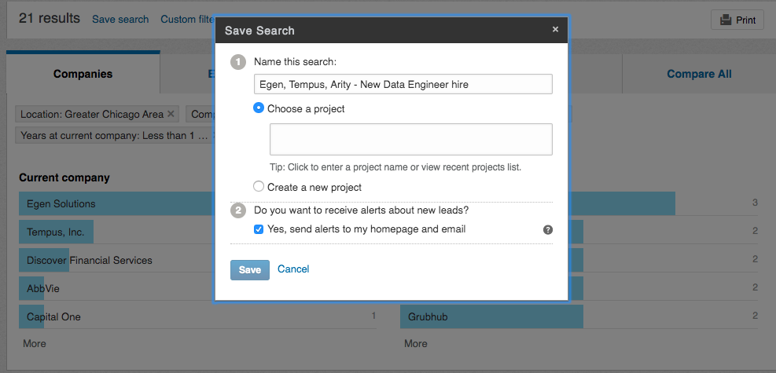

* Save the search – Client names – New Data Engineer – CHI
* Run the exact search as “Past” Instead of Current and Save that search to be notified anytime a Data Engineer leaves one of your Target Accounts

**Utilizing LinkedIn Jobs – Be alerted when a Company posts a job within your skillet**

Run a search in Standard LinkedIn under Jobs

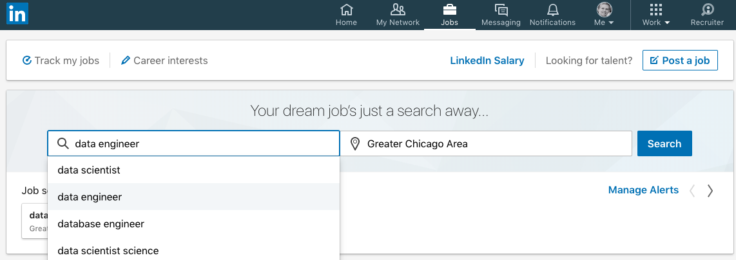

* Go to “Jobs”
* Search Data Engineer - Chicago Area

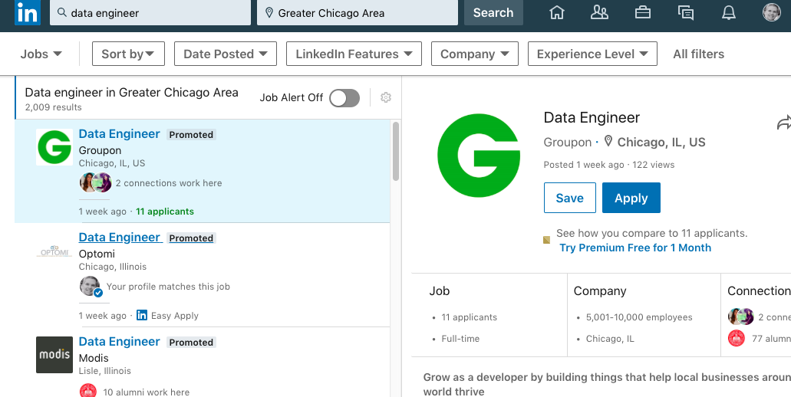

* Click “Job Alert Off / On Tab
* Select Daily / Weekly and the best way to stay notified (email or alerts)

